**Name:** Kanak Agrawal

**Email:** [Kanakagrawal2001@gmail.com](mailto:Kanakagrawal2001@gmail.com)

**Date**:01-02-2024

**Python Day-4**

**Question: NUMPY & PANDAS**

* **Creation of array with evenly spaced**

**Code:**

import numpy as np  
  
a = np.arange(1, 10)  
print(a)  
  
x = range(1, 10)  
print(x) # x is an iterator  
print(list(x))  
  
# further arange examples:  
x = np.arange(10.4)  
print(x)  
  
  
x = np.arange(0.5, 10.4, 0.8)  
print(x)  
  
  
np.arange(12.04, 12.84, 0.08)

**Output:**

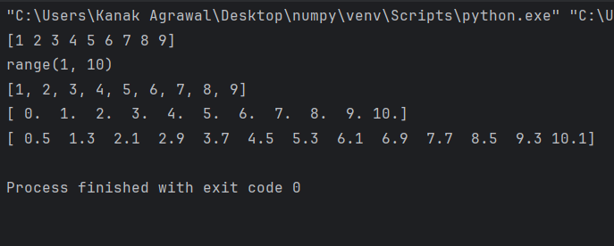

* **LINESPACE**

**Code:**

import numpy as np  
  
# 50 values between 1 and 10:  
print(np.linspace(1, 10))  
# 7 values between 1 and 10:  
print(np.linspace(1, 10, 7))  
# excluding the endpoint:  
print(np.linspace(1, 10, 7, endpoint=False))

**Output:**

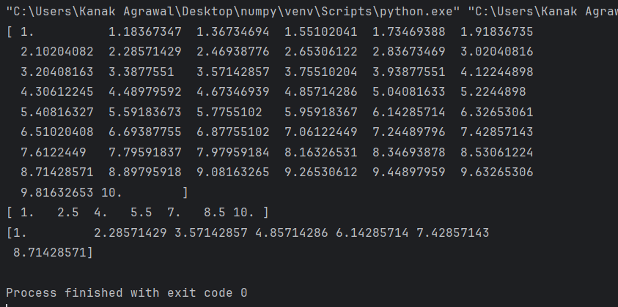

**Code:**

import numpy as np  
  
  
samples, spacing = np.linspace(1, 10, retstep=True)  
print(spacing)  
samples, spacing = np.linspace(1, 10, 20, endpoint=True, retstep=True)  
print(spacing)  
samples, spacing = np.linspace(1, 10, 20, endpoint=False, retstep=True)  
print(spacing)

**Output:**

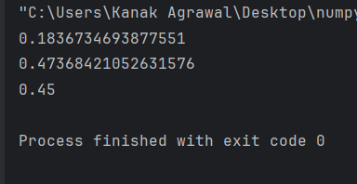

* **Filter data in pandas dataframe using query filter**

**Code:**

import pandas as pd  
  
# Sample DataFrame  
data = {'Name': ['Alice', 'Bob', 'Emma', 'Tom', 'Andrew'],  
 'Age': [25, 30, 22, 35, 28],  
 'Salary': [50000, 60000, 45000, 70000, 55000]}  
df = pd.DataFrame(data)  
  
# Query to filter data  
filtered_df = df.query("Age > 25 and Salary > 50000")  
print(filtered_df)

**Output:**

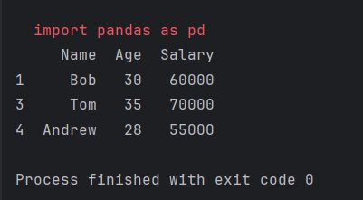

* **Get count by month and status using pandas dataframe apis**

**Code:**

import pandas as pd  
  
  
data = {'Date': ['2023-01-01', '2023-01-02', '2023-02-01', '2023-02-03', '2023-02-15'],  
 'Status': ['Open', 'Closed', 'Open', 'Closed', 'Open']}  
df = pd.DataFrame(data)  
  
# Convert 'Date' column to datetime type  
df['Date'] = pd.to_datetime(df['Date'])  
  
# Create 'Month' column  
df['Month'] = df['Date'].dt.to_period('M')  
  
# Group by 'Month' and 'Status', then get counts  
counts_by_month_status = df.groupby(['Month', 'Status']).size().reset_index(name='Count')  
  
print(counts_by_month_status)

**Output:**

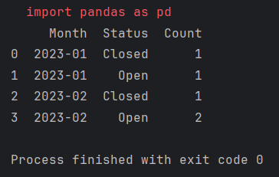

* **Inner Join between pandas dataframes**

**Code:**

import pandas as pd  
  
# Sample data for two DataFrames  
data1 = {'ID': [1, 2, 3, 4],  
 'Value1': [10, 20, 30, 40]}  
data2 = {'ID': [2, 3, 4, 5],  
 'Value2': [50, 60, 70, 80]}  
  
df1 = pd.DataFrame(data1)  
df2 = pd.DataFrame(data2)  
  
# Perform an inner join on 'ID'  
merged_df = pd.merge(df1, df2, on='ID', how='inner')  
print(merged_df)

**Output:**

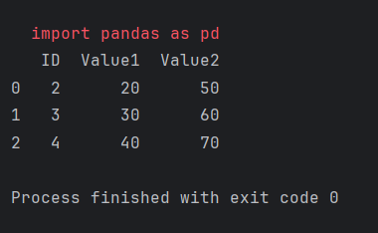

* **Sort data in pandas dataframe**

**Code:**

import pandas as pd  
  
# Sample DataFrame  
data = {'Name': ['pranshi', 'Kanak', 'dhruv', 'isha', 'gokul'],  
 'Age': [25, 30, 22, 35, 28],  
 'Salary': [50000, 60000, 45000, 70000, 55000]}  
df = pd.DataFrame(data)  
  
# Sort DataFrame by the 'Age' column in ascending order  
sorted_df = df.sort_values(by='Age')  
  
# Display the sorted DataFrame  
print(sorted_df)

**Output:**

